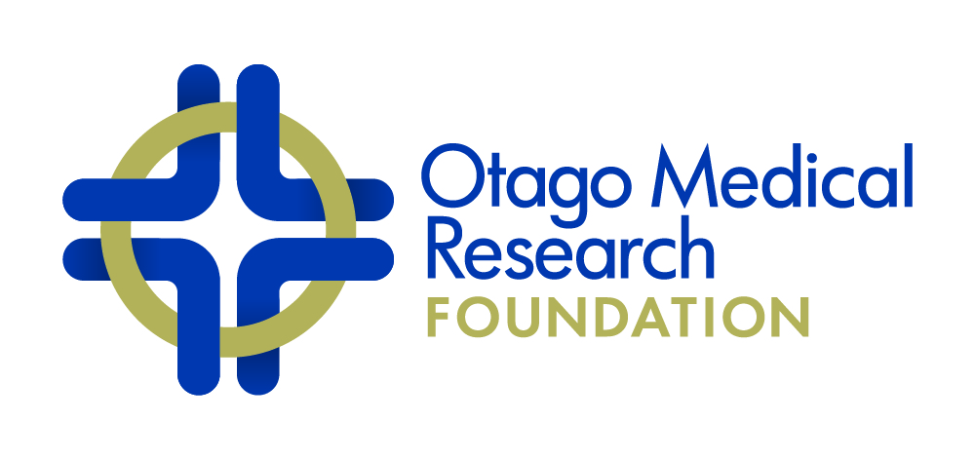

Deloitte, Secretaries
P O Box 1245, Dunedin Fax (03) 474 8650 Telephone (03) 474 8630

OMRF JACK THOMSON ARTHRITIS FUND 2020

INFORMATION FOR APPLICANTS

1. The Council of the Otago Medical Research Foundation Inc. (OMRF) invites applications from principal investigators based in the Otago region for financial support of medical research into the problems and treatment of arthritis (in accordance with the wishes of William John (Jack) Thomson).
Closing date Friday 13th November 2020 (2.00 pm). Please note that the University of Otago’s Research & Enterprise Office will require applications from University staff by Monday 9th November 2020 (9am).
2. Grants ($10,000 minimum, $40,000 maximum) and only for projects that are achievable within a one-year time frame will be made available for working expenses, including minor items of equipment, and salaries of research workers. Please note that PhD/MSc stipends and fees are not a fundable item. Applications solely for equipment will not be considered. Grants must be activated by 1 April 2021 at the latest and be completed within a 12-month period.
3. This year the total amount available is $80,000.
4. Applications for an extension of a current OMRF Jack Thomson Arthritis Grant may be considered. If an extension is requested, please provide with your application a report (see #7 below) on the outcome of your current grant.
5. Since the Foundation wishes to encourage the dissemination of information gained from research projects, provision of funds for publication costs (but not attendance at conferences) may be included in grant applications.
6. If awarded a grant, the Foundation requires (1) a one-paragraph updated lay abstract (approx. 150 words) by 31 May 2021, submitted electronically to your Research Office, written in terms understandable by laypersons, who are not specialists in your field of study, and (2) an image of yourself, your research team or your research - both abstract and image for inclusion in the Annual Report of the Foundation.
7. The Foundation requires a report on the outcomes of the grant. (maximum 5 pages: Lay Abstract with lay title, Scientific Abstract, Introduction, Methods, Results/Discussion, Acknowledgements, References) to be submitted electronically to your Research Office not more than three months after the finish date. The entire report MUST be written in terms understandable by laypersons and scientists who are not specialists in your field of study – this is essential for the OMRF to continue to obtain funding from sub-sponsors. The one-paragraph lay abstract will be placed on the OMRF’s website (http://omrf.otago.ac.nz/). An image of yourself, your research team or your research is also required for publicity purposes.
8. The Foundation expects that the financial support given by the Foundation will be acknowledged in any media coverage and resulting scientific publication(s) and conference abstracts, and that a copy of each such publication should be forwarded to the Chair of the OMRF Scientific Committee.
9. The Foundation expects that research funded by the Foundation shall be presented to a forum within Otago that is beyond the confines of a departmental seminar, and the Chair of the OMRF Scientific Committee shall be notified in advance.
10. A MS Word Document of the application and a PDF of the signed administrative agreement page should be submitted (via the University of Otago’s Research & Enterprise Office in the case of University staff) to the Chair of the OMRF Scientific Committee on A4 paper, in Arial 11-point font with margins no less than 2 cm, using the form below.

OMRF JACK THOMSON ARTHRITIS FUND

APPLICATION FORM 2020

Title of Project (up to 80 characters)
[type here]

Title, First and Family Name (PI) [type here]
Position [type here]
Department, Institution [type here]
Email address [type here]

Title, First and Family Name (AI) [type here]
Position [type here]
Department, Institution [type here]
Email address [type here]

Title, First and Family Name (AI) [type here, copy as needed]
Position [type here]
Department, Institution [type here]
Email address [type here]

Lay Abstract of Research
(about 100 words in language comprehensible to the non-specialist, and suitable for the OMRF website)
[type here]

Scientific Abstract of Research
(about 100 words in language comprehensible to the non-specialist)
[type here]

Details of Financial Support Requested (the addition of GST is NOT required; add rows as needed)
Consumables (item and purpose) | Cost per unit | No. of units | Total Cost
 |  |  | $
Salaries with related expenses | Salary Grade | FTE | $
Total Requested |  |  | $

Description of project (up to 4 pages maximum, not including references)
1. Background (up to a page)
[type here]

2. Methods, experimental design
[type here]

3. Timelines (including start and end dates; please note that projects must start by 1 April, 2021)
[type here]

4. Significance
[type here]

References (use a separate page/s as needed)

Other Information Required

1. Roles in this project, and relevant experience, of PI, all AIs and other named or unnamed personnel (up to one half page)
[type here]

2. CVs
Please attach at the end of this application a standard NZ R,S&T CV (link below) for each PI and named AIs. Only complete Parts 1 and 2a. You may wish to identify using asterisks publications that are relevant to the current application.
http://www.otago.ac.nz/research/forms/5_NZ%20RS&T%20CV%20Template/

3. Facilities available
[type here]

4. Other support received or under request for this project, including financial support from Departments
[type here]

5. Please list ALL previous support received from the OMRF on which you were PI or AI, plus outcomes and publications (including date of final report for any OMRF-funded projects over the last 2 years):

OMRF-funded project name/s [type here]
Outcomes and Publications [type here]
Date of final report/s [type here]

6. For the PI only, please provide a list of research grants (title, funding body, dates and $s) received over the last 5 years [type here].

7. Administrative Agreement (See Below)

Please Note:
Ethics and Safety Compliance Approvals
Agreement by the Foundation to fund a project and release funds is subject to receipt by the Chair of the Scientific Committee of evidence of appropriate Ethics or Safety Compliance approvals.

Independent Review
The Foundation reserves the right to seek independent expert assessment concerning the merits of the proposed research.

Outcome of grant applications
Will be advised mid December

Enquiries of a scientific nature
Should be directed to the Chair of the OMRF Scientific Committee

Chair of the OMRF Scientific Committee:
Professor Greg Jones greg.jones@otago.ac.nz
c/ Department of Surgical Sciences (DSM), University of Otago

ADMINISTRATIVE AGREEMENT:

The applicant undertakes to conduct this described project according to the conditions established by the Otago Medical Research Foundation Inc. (OMRF).

The Heads of the Department and Institution (Medical School, Hospital etc. where appropriate) approve the application.

The sponsoring body agrees and undertakes to support the project described in this application by making available accommodation, basic facilities and services necessary for its fulfilment.

Signed …………………………………………………. Applicant ……………………2020

…………………………………………………. Head of Department ……………………2020

Authorised official on behalf of ……………………………………. (identify sponsoring body)

If the University of Otago, signature required from the Deputy Vice-Chancellor (Research and Enterprise) or nominee.

…………………………………………………. ……………………2020

