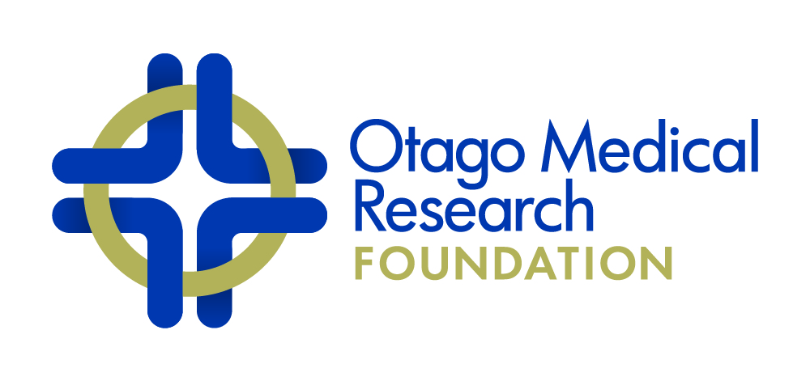
Deloitte, Secretaries
P O Box 1245, Dunedin
Fax (03) 474 8650
Telephone (03) 474 8630
ANNUAL GRANTS 2022 including
OTAGO COMMUNITY TRUST GRANTS 2022

INFORMATION FOR APPLICANTS

1. The Council of the Otago Medical Research Foundation Inc. (OMRF) invites applications from principal investigators based in the Otago region for financial support of medical research relating to human health or the basic sciences.
Closing date is Friday 17 June 2022 (2.00 pm). Please note that the University of Otago’s Research & Enterprise Office will require applications from University staff by Friday 10 June 2022 (2.00 pm).
2. Grants (normally <$40,000 and for projects that are achievable within a one-year time frame) will be made available for working expenses, including minor items of equipment, and direct salaries of research staff. PhD/MSc stipends, student fees and grant overheads are not fundable items. Applications solely for equipment will not be considered. Grants must be activated by 1 October 2022 at the latest and be completed within a 12-month period.
Offers of Grants will be made subject to having all ethical and locality assessment approval in place by the 1 October unless the recorded timeline of the project specifies otherwise.
3. The amount available from the Foundation’s current resources for the Annual Grant Round is about $120,000. We anticipate an additional $80,000 will be made available to the Foundation by the Otago Community Trust, known when the OMRF Scientific Committee meets to consider grant applications. In addition, two areas of research have been identified for targeted funding by Foundation sponsors
A. Health in the Elderly. Approximately $40,000 will be made available for research with a focus on health in the elderly.
B. Multiple Sclerosis. Approximately $20,000 will be made available for research focussed on Multiple Sclerosis. This funding is via the New Zealand Multiple Sclerosis Research Trust (NZMSR) and, at the Trustees discretion, there is the possibility of to awarding an extra up to $20k for projects of merit.
4. Applications for an extension of a current OMRF Annual Grant may be considered. If so, please provide with your application a final report (see #7 below) on the outcome of your current grant.
5. Since the Foundation wishes to encourage the dissemination of information gained from research projects, funds for publication costs (but not attendance at conferences) may be included in grant applications.
6. If awarded a grant, the Foundation will require (1) a one-paragraph updated lay abstract (approx. 150 words) by 31 May 2023, written in terms understandable by laypersons, and (2) an image of yourself, or your research team, for inclusion in the Annual Report of the Foundation.
7. The Foundation requires a report on the grant outcomes (maximum 5 pages: Lay Abstract with lay title, Scientific Abstract, Introduction, Methods, Results/Discussion, Acknowledgements, References) to be submitted electronically to your Research Office no later than three months after the finish date. The entire report MUST be written in terms understandable by laypersons and scientists who are not specialists in your field of study. Please be aware that this report will be shared with any sub-sponsors and, as such, is an important aspect of the Foundations ongoing fundraising initiatives. The lay abstract will also be placed on the OMRF’s website (http://omrf.otago.ac.nz/).
8. The Foundation expects that the financial support given by the Foundation or the Otago Community Trust will be acknowledged in any media coverage, resulting scientific publication(s) and conference abstracts and that a copy of each such publication should be forwarded to the Chair of the OMRF Scientific Committee.
9. The Foundation expects that research funded by the Foundation or the Otago Community Trust shall be presented to a forum within Otago that is beyond the confines of a departmental seminar, and the Chair of the OMRF Scientific Committee shall be notified in advance.
10. The Application Form is below (please strictly adhere to the format instructions). All applications should be submitted in MS Word format (preferably electronically signed), along with a PDF of any physically signed declaration page. Applications from University of Otago staff should be submitted via the appropriate Research Advisor. Applications from all others should be submitted to Professor Greg Jones, the Chair of the OMRF Scientific Committee (via info@omrf.org.nz, with a subject title: OMRF annual grant application).
11. The OMRF is a signatory of the Openness Agreement on Animal Research and Teaching in New Zealand. As part of our commitment to this agreement an additional section has been added to the 2022 form, asking you to briefly explain the use of animals and confirming how the research design adheres to the 3Rs principals. This section (if needed) will not be included in the page count.

Outcome of grant applications will be advised late-July

Enquiries of a scientific nature should be directed to:
Chair of the OMRF Scientific Committee:
Professor Greg Jones greg.jones@otago.ac.nz
c/ Department of Surgical Sciences (DSM), University of Otago

ANNUAL GRANTS &
OTAGO COMMUNITY TRUST GRANTS
APPLICATION FORM 2022

Title of Project (up to 80 characters) [type here]

Title, First and Family Name (Principal investigator) [type here]
Position [type here]
Department, Institution [type here]
Email address [type here]

Title, First and Family Name (Co-investigator) [type here]
Position [type here]
Department, Institution [type here]
Email address [type here]

Title, First and Family Name (Co-investigator) [type here]
Position [type here]
Department, Institution [type here]
Email address [type here]

Lay Abstract of Research (about 100 words in language comprehensible to general public, and suitable for the OMRF website)
[type here]

Scientific Abstract of Research (about 100 words in language comprehensible to the non-specialist)
[type here]

Details of Financial Support Requested (the addition of GST is NOT required; add rows as needed)
Consumables (item and purpose) | Cost per unit | No. of units | Total Cost
 |  |  | $
Salaries with related expenses | Salary Grade | FTE | $
Total Requested |  |  | $

Description of project (up to 4 pages, not including references in Arial 11pt – Do not adjust the margins)

1. Background
[type here]

2. Methods, experimental design
[type here]

3. Timelines (including start and end dates; please note that projects must be in a position to start by 1 October 2022).
[type here]

4. Significance
[type here]

References (use a separate page/s as needed)

Use of Animals for Research
The OMRF is a signatory of the Openness Agreement on Animal Research and Teaching in New Zealand. As part of our commitment to this agreement we ask that applicants provide a brief justification, in lay language, for the use of animals to answer your research question (if applicable). In addition, please confirm how the research design adheres to the 3Rs principals. This section (if needed) will not be included in the page count.

[type here]

Other Information Required

1. Roles, and relevant experience, of PI, all AIs and other named or unnamed personnel (up to one half page)
[type here]

2. CVs
Please attach at the end of this application a standard NZ RS&T CV (link below) for each PI and named AIs. Only complete Parts 1 and 2a. You may wish to identify using asterisk publications that are relevant to the current application. http://www.otago.ac.nz/research/forms/5_NZ%20RS&T%20CV%20Template/

3. Facilities available
[type here]

4. Other support received or requested for this project, including financial support from Departments
[type here]

5. Please list ALL previous support received from the OMRF on which you were PI or AI plus outcomes and publications (including date of final report for any OMRF-funded projects over the last 2 years):

OMRF-funded project name/s [type here]
Outcomes and Publications [type here]
Date of final report/s [type here]

6. For the PI only, please provide a list of research grants received over the last 5 years (title, funding body, dates and $ amount)
[type here]

7. Administrative Agreement (see below)

Please Note:
Ethics and Safety Compliance Approvals
As per point 2 in the ‘Information for Applicants’, offers of Grants will be made subject to having all ethical and locality assessment approval in place by the 1 October, unless the recorded timeline of the project specifies otherwise. Therefore, the agreement by the Foundation to fund a project and release funds is subject to receipt by the Chair of the Scientific Committee of evidence of appropriate Ethics or Safety Compliance approvals.

Independent Review
The Foundation reserves the right to seek independent expert assessment concerning the merits of the proposed research.

ADMINISTRATIVE AGREEMENT:
The applicant undertakes to conduct this described project according to the conditions established by the Otago Medical Research Foundation Inc. (OMRF).

The Heads of the Department and Institution (Medical School, Hospital etc. where appropriate) approve the application.

The sponsoring body agrees and undertakes to support the project described in this application by making available accommodation, basic facilities and services necessary for its fulfilment.

Signed …………………………………………………. Applicant

……………………2022

…………………………………………………. Head of Department

……………………2022

Authorised official on behalf of ……………………………………. (identify sponsoring body)

If the University of Otago, signature required from the Deputy Vice-Chancellor (Research and Enterprise) or nominee.

…………………………………………………. ……………………2022

